EXPERIMENT 2.2: Data Split up and Cross validation.
AIM:
To evaluate a K-Nearest Neighbors (KNN) classifier using five-fold cross-validation.
ALGORITHM:
- Import Pandas and the required Scikit-learn modules.
- Load the dataset from data.csv.
- Select Hours_Studied, Attendance, and Assignments as input features.
- Select Result as the target variable.
- Split the dataset into training and testing sets in an 80:20 ratio.
- Create a KNN classifier with n_neighbors=3.
- Perform five-fold cross-validation using cross_val_score().
- Display the five cross-validation scores.
- Calculate and display the average accuracy.
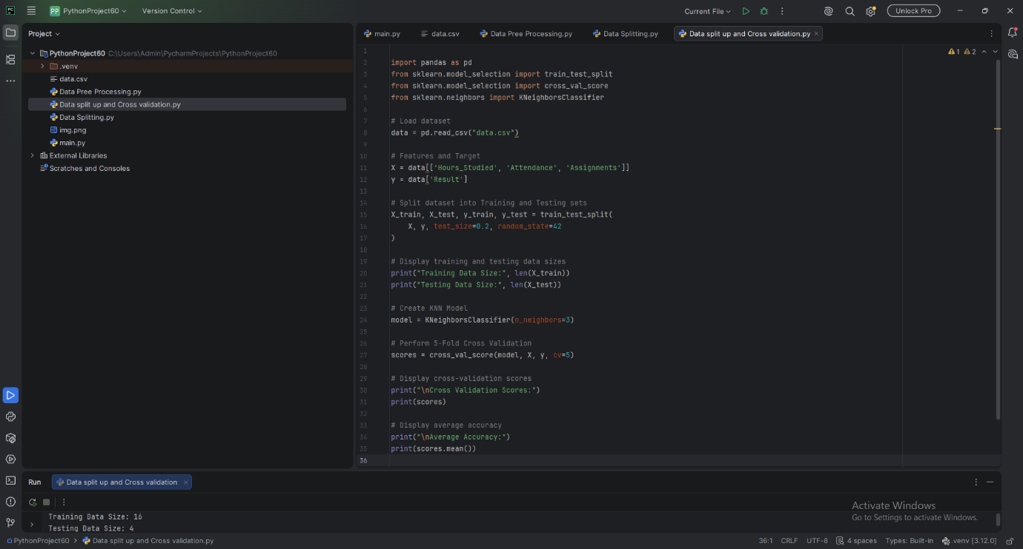
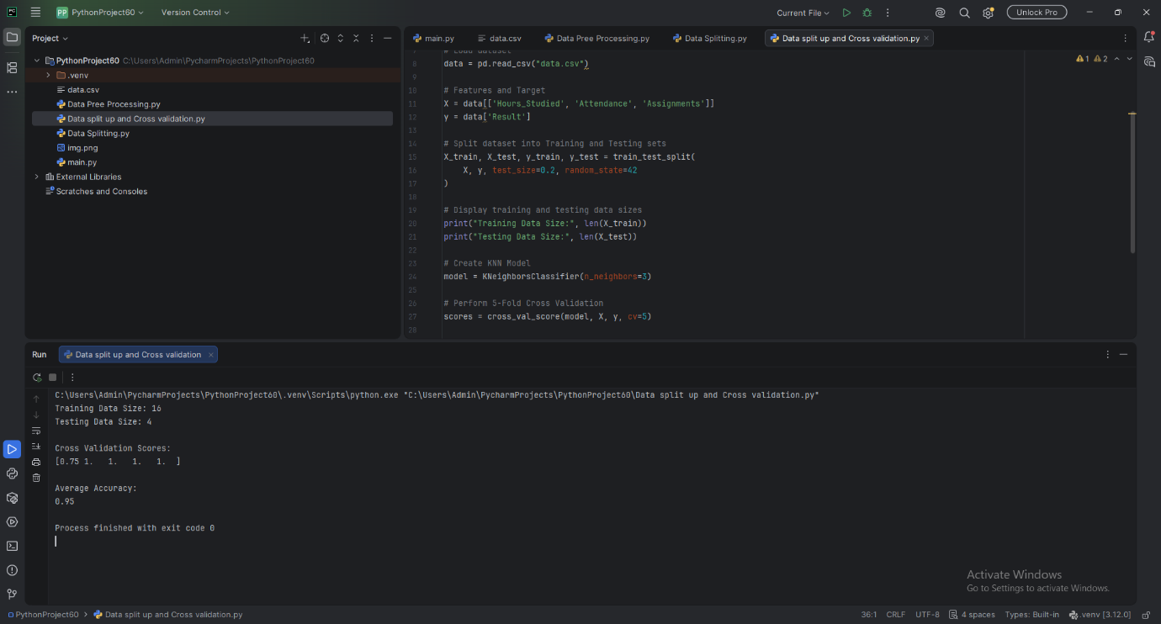

RESULT:
Five-fold cross-validation was successfully performed, and the individual scores and average accuracy were obtained to evaluate the KNN classifier.

